1. Ensure you have the moodle instance running and you are logged in as admin
   1. To log in as admin navigate to the top right corner and sign in using the moodle username and password in the moodle.yaml file
2. Unblock HTTPS on Moodle
   1. Navigate to “Site Administration” and “General”

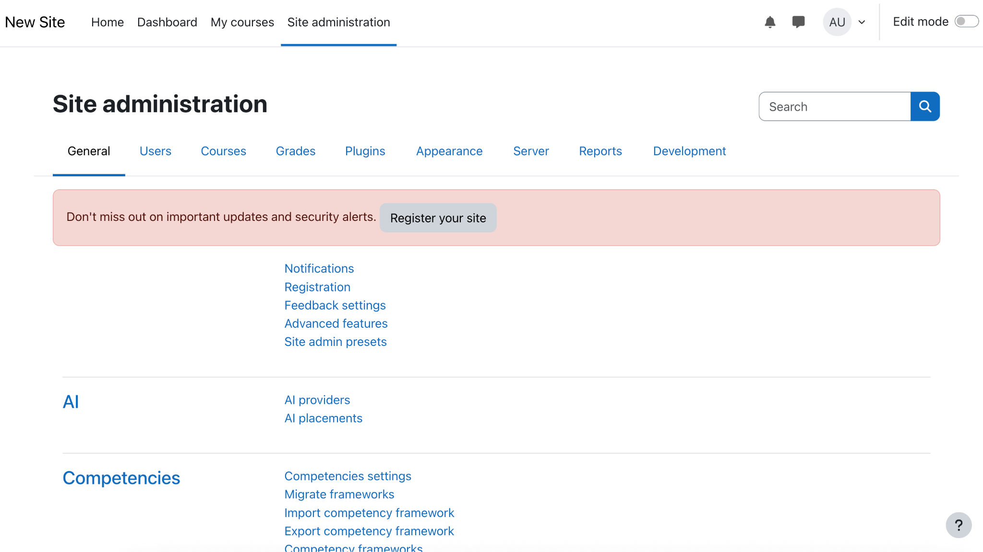

* 1. Scroll down to the “Security” section and click on “HTTP Security”

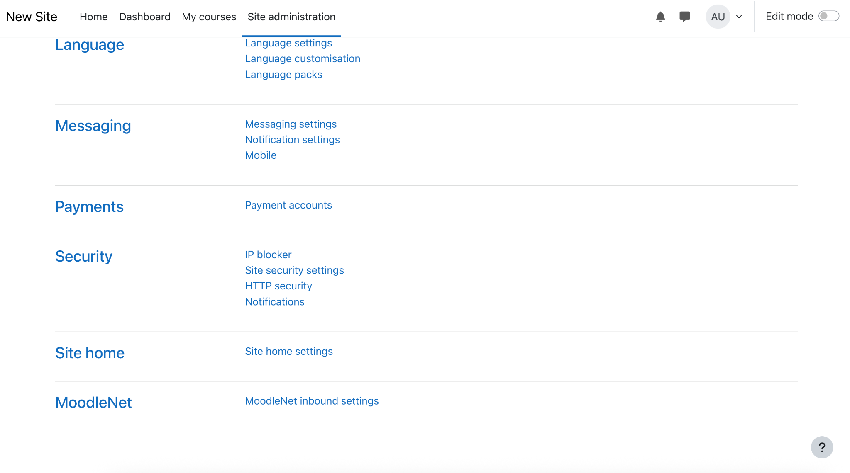

* 1. Uncheck “Secure cookies only” and delete and the IP addresses in “cURL blocked hosts list” and save your changes with the “Save Changes” button at the bottom of the page

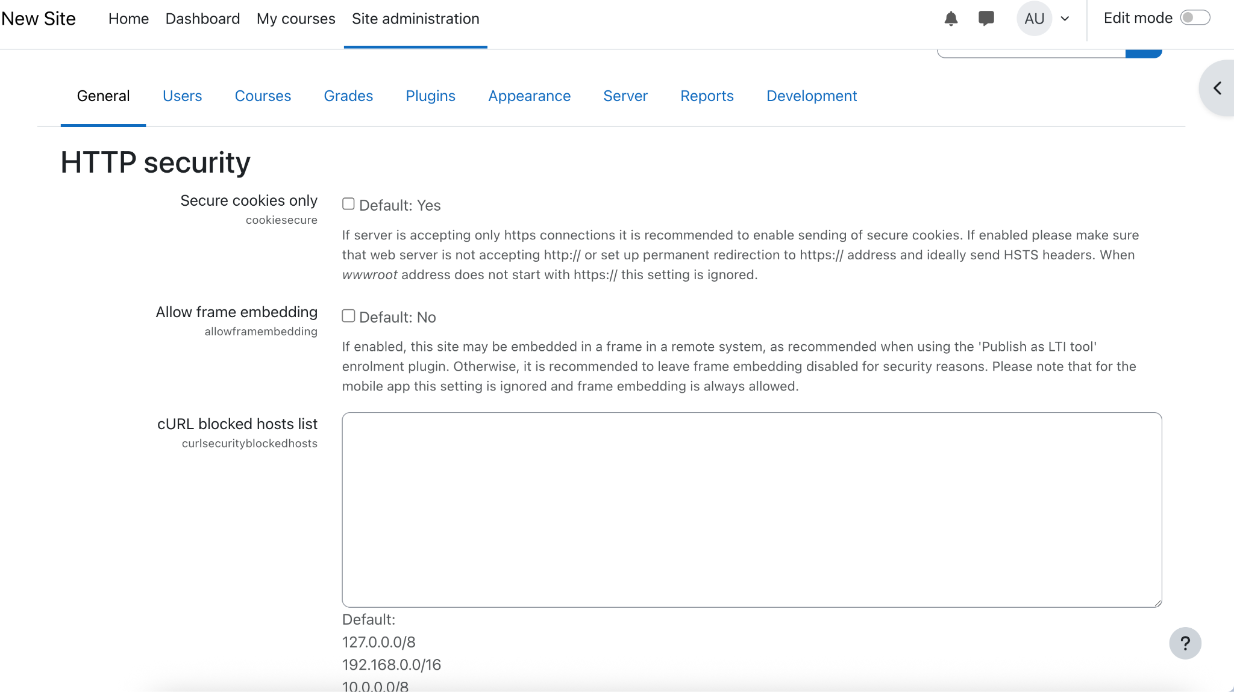

1. Download the data files in this folder: [Data Files](https://drive.google.com/drive/folders/1GKxbWK8ZTO3Dz-X4Thz83u9fjJYfhiD9)
2. Ensure that you have the “moodle_role” role selected

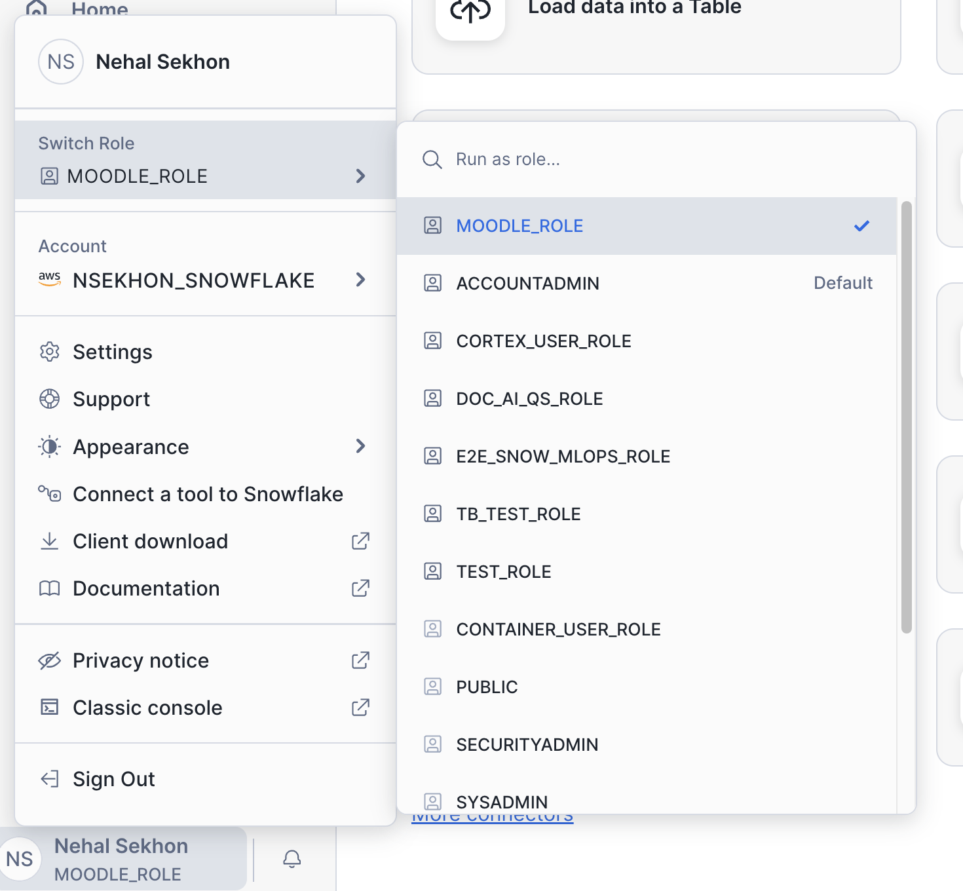

1. Navigate to the Snowflake snowsight and on the left navigation bar hover over the “Data” tab (has a database icon) and click on “add data”
2. Click on “Load files into a stage” and fill in the fields as below and upload (NOTE: Ensure that you specify the path to a folder correctly)

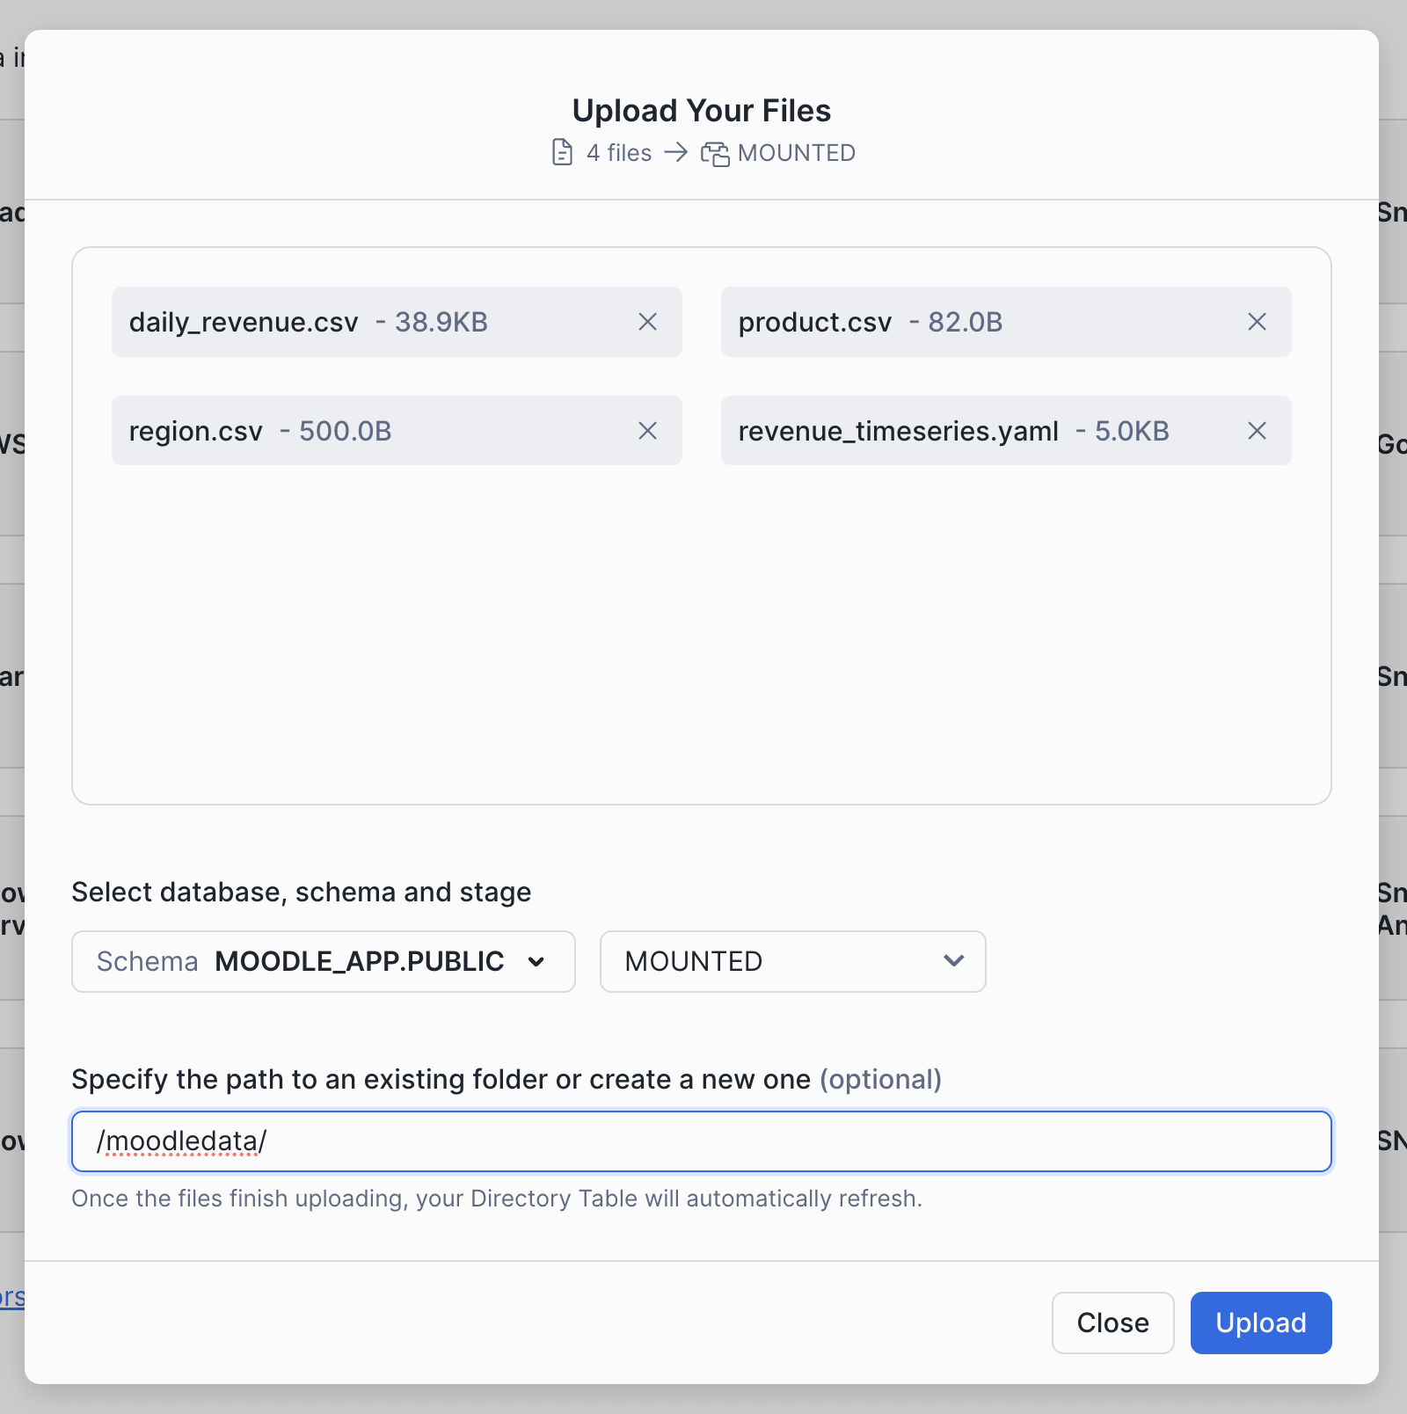

1. Run the following commands in Snowflake Snowsight



USE ROLE SECURITYADMIN;

GRANT DATABASE ROLE SNOWFLAKE.CORTEX_USER TO ROLE moodle_role;

USE ROLE MOODLE_ROLE;

USE DATABASE moodle_app;

-- Fact table: daily_revenue

CREATE OR REPLACE TABLE moodle_app.public.daily_revenue (

date DATE,

revenue FLOAT,

cogs FLOAT,

forecasted_revenue FLOAT,

product_id INT,

region_id INT

);

-- Dimension table: product_dim

CREATE OR REPLACE TABLE moodle_app.public.product_dim (

product_id INT,

product_line VARCHAR(16777216)

);

-- Dimension table: region_dim

CREATE OR REPLACE TABLE moodle_app.public.region_dim (

region_id INT,

sales_region VARCHAR(16777216),

state VARCHAR(16777216)

);

COPY INTO moodle_app.public.DAILY_REVENUE

FROM @MOODLE_APP.PUBLIC.MOUNTED

FILES = ('moodledata/daily_revenue.csv')

FILE_FORMAT = (

TYPE=CSV,

SKIP_HEADER=1,

FIELD_DELIMITER=',',

TRIM_SPACE=FALSE,

FIELD_OPTIONALLY_ENCLOSED_BY=NONE,

REPLACE_INVALID_CHARACTERS=TRUE,

DATE_FORMAT=AUTO,

TIME_FORMAT=AUTO,

TIMESTAMP_FORMAT=AUTO

EMPTY_FIELD_AS_NULL = FALSE

error_on_column_count_mismatch=false

)

ON_ERROR=CONTINUE

FORCE = TRUE ;

COPY INTO moodle_app.public.PRODUCT_DIM

FROM @MOODLE_APP.PUBLIC.MOUNTED

FILES = ('moodledata/product.csv')

FILE_FORMAT = (

TYPE=CSV,

SKIP_HEADER=1,

FIELD_DELIMITER=',',

TRIM_SPACE=FALSE,

FIELD_OPTIONALLY_ENCLOSED_BY=NONE,

REPLACE_INVALID_CHARACTERS=TRUE,

DATE_FORMAT=AUTO,

TIME_FORMAT=AUTO,

TIMESTAMP_FORMAT=AUTO

EMPTY_FIELD_AS_NULL = FALSE

error_on_column_count_mismatch=false

)

ON_ERROR=CONTINUE

FORCE = TRUE ;

COPY INTO moodle_app.public.REGION_DIM

FROM @MOODLE_APP.PUBLIC.MOUNTED

FILES = ('moodledata/region.csv')

FILE_FORMAT = (

TYPE=CSV,

SKIP_HEADER=1,

FIELD_DELIMITER=',',

TRIM_SPACE=FALSE,

FIELD_OPTIONALLY_ENCLOSED_BY=NONE,

REPLACE_INVALID_CHARACTERS=TRUE,

DATE_FORMAT=AUTO,

TIME_FORMAT=AUTO,

TIMESTAMP_FORMAT=AUTO

EMPTY_FIELD_AS_NULL = FALSE

error_on_column_count_mismatch=false

)

ON_ERROR=CONTINUE

FORCE = TRUE ;



1. Download cortexanalyst.zip and install the plug in following the instructions [Moodle Plugin Installation Guide](https://docs.google.com/document/d/1d3pSE2xtdJ-uHx__we4_w6Q8Kxutkt6hPldRUy471y0/edit?tab=t.0)
2. During the installation process you will be asked to add the snowflake hostname

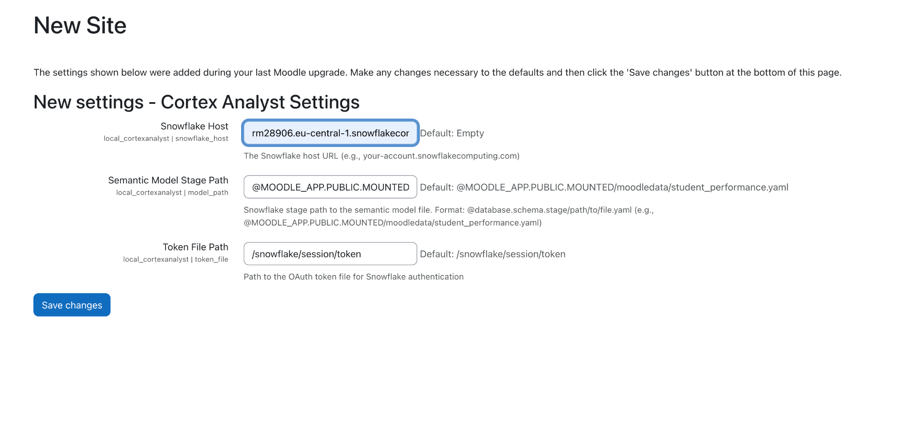

1. Navigate to <ingressurl>/local/cortexanalyst/index.php
2. Sample question to ask
   1. For each month, what was the lowest daily revenue and on what date did that lowest revenue occur?